Alaska Indoor Gardening Curriculum
Eggheads Lesson
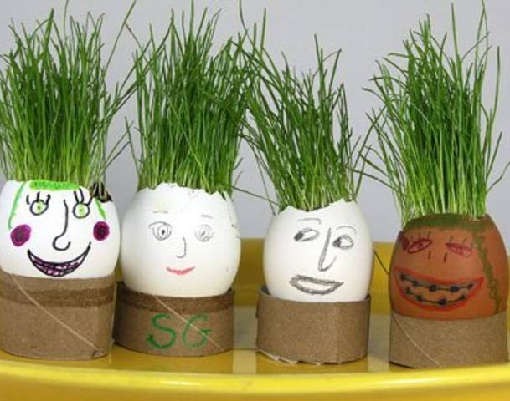
Concept Objective: Soil and Plants
Time: 40 minutes
Setting: Indoors
Activities: Eggheads
Materials Needed:
Egg shells, with tops carefully removed
Grass seed
Potting Soil
Toilet Paper Tubes – cut into smaller rounds
- Or Egg Cartons cut up into individual cups
- Or Keurig style K-Cups (cleaned)
Small Paper Cups
Googlie eyes
Pipe Cleaners
Plastic Jewels
Sequins
Sharpie Markers
Plastic Spoons

Procedure:
- Give each student an egg and a holder.
- Have the students decorate their egg with a face and some crafty decorations (googlie eyes, sequins, markers, tissue paper, stickers) and decorate holder.
- Once they have finished decorating their egg (and it hasn’t cracked) help them put a small amount of dirt into the egg with a spoon. Fill about ¾ full with dirt.
- Sprinkle with grass seeds and water. Place egg in holder. Set aside and admire.
- Advise students to water lightly every day. If they water regularly, the grass will grow and look like hair.
